$$Setup SSH in windows$$

1. **Go to Powershell repository (https://github.com/PowerShell/Win32-OpenSSH/releases)**
   1. Download latest openSSH.zip (either 32 or 64bit depends on system architecture)
   2. Extract it to C-Drive
2. **Set path in Environment Variable**
   1. Right click This PC 🡺select properties
   2. Go to Advanced System setting (in left side of opened window)
   3. Click on Environment Variable
   4. Add openSSH path (one where ssh.exe is present) in path variable (either in user variable or system variable as per requirement)
3. 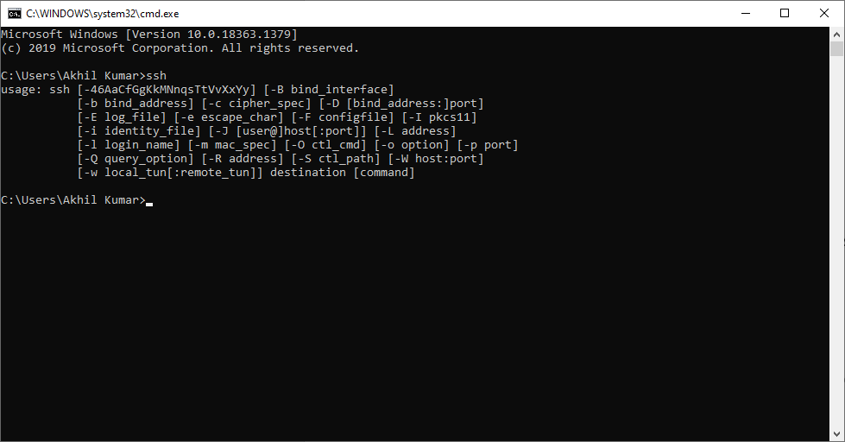**Restart CMD**

Check for ssh